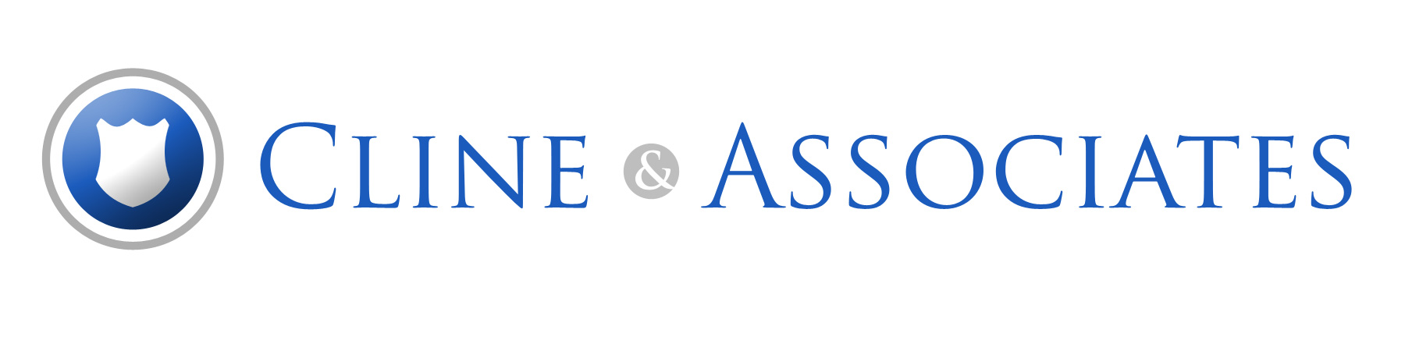
LABOR LAW TRAINING CONFERENCE
May 20, 2024 | May 21, 2024
Day 1: “Contract Negotiation and the Collective Bargaining Rights of Washington Public Safety Labor Organizations”
Date: May 20, 2024 Time: 8:00 a.m. – 5:00 p.m.
Key Topics
- Negotiating a contract: Tactics and Techniques
- Emerging Trends in Public Safety Labor Contracts: Navigating through Troubled Waters
- The Right to Collective Bargaining: What is Negotiable and What is a “Management Right”
- Unfair Bargaining Tactics: What They Are and What You Can Do About Them
- Interest Arbitration: How to Prepare and What to Expect
- Interpreting and Administering Your Contract: Common Problems and Issues
- Getting Paid Your Due: The Hour and Overtime Requirements of the Fair Labor Standards Art
Day 2: “Rights of Washington Public Safety Labor Organizations and Their Members” Date: May 21, 2024 Time: 8:00 a.m. – 5:00 p.m.

Key Topics
- Discipline Investigations: Important Pre-disciplinary Rights of Your Members Including Garrity, Weingarten and Loudermill
- “Just Cause” Discipline: What It is and How to Enforce Your Members’ Rights to It
- Common Types of Discipline Issues Facing Public Safety Labor Organizations and What to do About Them
- You Have Constitutional Rights Too: The Rights of Public Safety Employees to Free Speech, Privacy and Other Important Civil Rights
- Rights Critical Incidents Situations: What Every Public Safety Employee Needs to Know
- Facing Disabilities: Identifying and Protecting the Rights of Employees with Medical Limitations
- Handling Grievances: Complying with the “Duty of Fair Representation” That You Owe Your Members
- Being Left Alone When You’re Just Doing Your Job: The Right of Union Representatives to be Free From Discrimination and Retaliation
Training Conference Held at:  Pickering Barn  1730 10th Avenue NW  Issaquah, WA 98027  Questions or comments?  Email us at clinelawfirm@clinelawfirm.com or call 206-838-8770 | Sign Up Now!  Fill out the registration form attached and return it to Cline & Associates.
 | CONFERENCE FEE: $185.00 per day – Fee discounted to $150.00 per day for Cline & Associates Clients and Premium Website Subscribers

LABOR LAW TRAINING CONFERENCE REGISTRATION FORM
Please register for one or both training conferences using this registration form:

Total Attendees |  | _____$185.00 for non-clients  _____$150.00 for Cline & Associates Clients and Premium Website Subscriber rate)
Total $

ATTENDEE CONTACT INFORMATION

Guild Name | Name of Attendee | Email Address | Phone Number | Day 1 | Day 2
Please note any dietary restrictions and email those to clinelawfirm@clinelawfirm.com

Please make check payable to: Cline & Associates.

Training Conference Fee Includes:
- Continental Breakfast
- Lunch Buffet
- Snacks and Drinks Made Available Throughout the Day
- Complimentary Happy Hour Following Monday’s Training; and
- A Free Copy of Jim Cline’s Revised and Published Book: The Rights of Washington Public Safety Employees: Representative Manual, 2nd Edition
- Supplemental Training Materials to Assist in Day-to-Day Contract Administration
Mail Payment To: Phone: 206-838-8770
Cline & Associates Fax: 206-838-8775
1606 Huckleberry Circle Email: clinelawfirm@clinelawfirm.com
Issaquah, WA 98029 www.clinelawfirm.com

